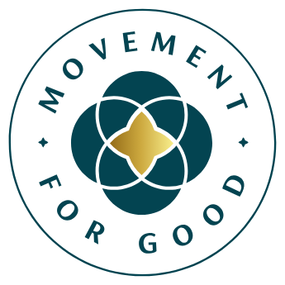

[Insert date]

Help [Insert name of charity] secure £5,000
from Benefact Group

[Your charity] is calling for nominations to receive a £5,000 Benefact Group Movement for Good Award.
[Your charity] is calling on members of the public to nominate them for a chance to be awarded £5,000 as part of Benefact Group’s Health & Wellbeing Special Draw, which will award a share of £50,000.
Benefact Group’s Movement for Good Awards gives over £1million away to charities and good causes every year.
How to nominate: The nomination window for health and wellbeing charities is open from Monday 11 to Sunday 24 May. It’s quick and easy to nominate [your charity] online at https://movementforgood.com/health
Every nomination strengthens [your charity]’s chance of being selected. If chosen, they plan to [insert information about how your charity will use the £5,000 and the impact it will make]. They’re encouraging supporters to spread the word on social media and invite friends and family to nominate them as well. Winners will be chosen at random, and the more nominations [your charity] receives, the greater their chance of being selected.
[Insert quote from your charity spokesperson which highlights the great work your charity does and encourages people to nominate them].
Mark Hews, Group Chief Executive of Benefact Group, said: “We’re delighted to be able to give over £1 million to good causes every year through our Benefact Group Movement for Good Awards. For many health and wellbeing charities, a £5,000 grant can make a real and immediate difference, which is why these awards matter so much.
“Benefact Group is a collection of specialist financial services companies owned by a charity, and our unique structure means giving back is built into everything we do. All of our available profits go to good causes, enabling us to donate more than £275 million to charities to date”

Movement for Good is funded by EIO plc, part of the Benefact Group.

***ENDS***

Notes for editors

Contact details [Who should the journalist contact for more information]

About [your charity]
[Use this space to include some information about your charity, bullet point the information and don’t have more than two or three points here]. For more information visit [insert your web address]

About the Movement for Good Awards
Benefact Group’s Movement for Good Awards is giving away over £1,000,00 in 2026 to help charities change lives for the better. For more information visit www.movementforgood.com

About Benefact Group
Benefact Group is a specialist financial services organisation with a unique mission: to donate all its available profits to charity. As an independent group owned by the registered charity Benefact Trust, its diverse family of businesses - including Ecclesiastical Insurance - offers expertise in specialist insurance, investment management, and broking and advisory services across the UK, Australia, Canada, and Ireland.
Over the past decade, Benefact Group has established itself as the third-largest corporate contributor to charitable causes in the UK, donating over £275m to charities since 2014. Find out more here: www.benefactgroup.com

